Argument for appeal request for Georgie

- The Housing Act (HA) 2004 introduced the management and control of Houses of Multiple Occupation (HMO) because there were concerns that such properties were vulnerable to mismanagement that could endanger their occupants. Licensing was introduced to control not only the properties themselves but also the persons responsible for their management.
- A HMO licence checks that both the property and the manager/owner are fit for purpose.
- We do not find authorities on s68(6) that are relevant and so base our arguments here on the purpose of the HA 2004.
- Considering the current case, if the decision were to be correct, this would imply that a Rent Repayment Order (RRO) cannot be made against a person who has acquired a previously licensed property, so long as the former owner’s licence is not revoked. The new owner could then rely on their RRO immunity, knowing that very few unlicensed HMOs are actually prosecuted by councils anyway, and perhaps, as a result, decide to remain unlicensed. The chances of the council learning of the sale and revoking the licence would also be slim. This would give rise to an unlicensed HMO run by an unverified person largely immune to prosecution. The tenants would have no protection afforded by a valid licence and associated conditions. This undesirable consequence was certainly not intended by the Act of 2004 and has potentially wide-ranging implications for the enforcement of the Act.
- As an additional consideration, the Rent Repayment Order legislation was brought about to allow occupants to reclaim their rent from a potentially illegal contract: the rental of an illegal HMO. The HA 2004 specifically required tenants to continue paying their rent and RROs were introduced as a way for them to recoup these payments. This way the legislation intended to avoid the chaos of tenants withholding rent for an illegal contract (see: Hansard 3 nov04 vol666 col329). How could a tenant achieve what was intended by the Act, in this case, where the licence holder is no longer the “appropriate person” because they no longer manage the property (having sold it) and the new owner is held by the Tribunal to be immune to a RRO application? Clearly, this was not an intention of the Act.
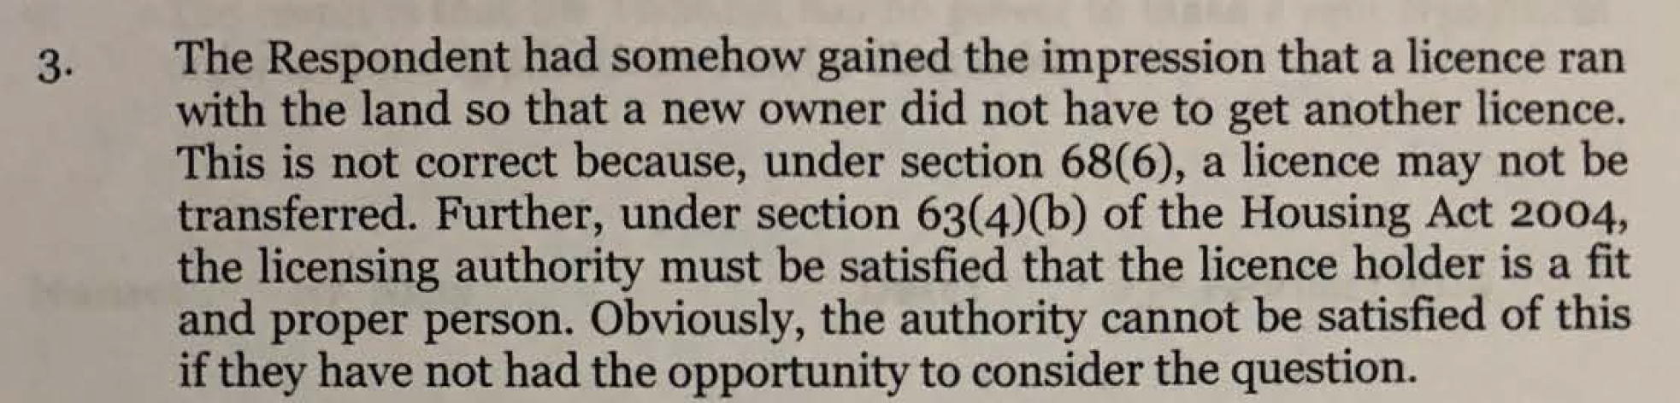
- The Tribunal itself provides the best argument, against its own decision’s conclusion, at 3:

- A HMO licence is associated with a property and a person. Indeed, when the named licence-holder dies, the licence dies: Housing Act 2004 (HA) s68(7). This shows clearly that a licence cannot continue to be valid without the named person in control.
- As Judge Nicol correctly states, there is no specific provision for what happens in other cases, such as a sale. There are also a number of other situations when a property might be transferred other than a sale: granting of a long lease, gift to another person, exchange, settlement into a trust etc. None of these are specifically provided for either in the Act. However, the Housing Act 2004 deals efficiently with all of these under 68(6): “a licence may not be transferred”. There is no need for a specific provision for each of the above situations in the legislation.
- The only specific provision in this regard is for the situation when a licence holder dies at 68(7). Clearly, a death may not be predictable and so there needed to be specific provision for this situation to allow for a moratorium in the licensing arrangements: hence the provision for an automatic Temporary Exemption Notice (TEN) on death.
- All other transfers are predictable and needed no further provision for transition arrangements other than 68(6).
- Other than the TEN on death, the sale of a property is essentially very similar to the situation when a licence holder dies:
- In both cases the licence holder is no longer the owner of the property
- In both cases the property is transferred to another person, who then becomes the “appropriate person” with control of the HMO and with a duty to license
- The property remains licensable according to its use in both cases
- A seller cannot possibly be held responsible for a HMO after its sale: all control and responsibility has been ceded to the new owner through the contract of sale. The former owner is no longer the “appropriate person” and so a RRO cannot be brought against them nor could they be fined for any breach which occurs after the sale. We are not aware of any cases where the contrary has been upheld. Therefore their responsibilities for the property come to an end with the sale just as surely as if they had come to their own end.
- We contend that the sale of a property, and any other transfer should be treated similarly to the death of a licence holder, except, of course, that there is no TEN and therefore the new owner becomes immediately responsible for licensing.
- At 7. The Tribunal argues that “There is no provision for the licence to terminate automatically, without a decision from the authority, other than on the death of the licence holder…”.
- This is not correct. For example, all licences are granted for a fixed term and they expire automatically at the end of that term. The same is true for licences under a selective scheme when the scheme itself expires. Similarly on sale, or other transfer of the property, the licence becomes automatically invalid and a new owner/manager must apply for a new licence. The old licence is necessarily defunct and only has value for historic (pre-sale etc.) responsibilities.
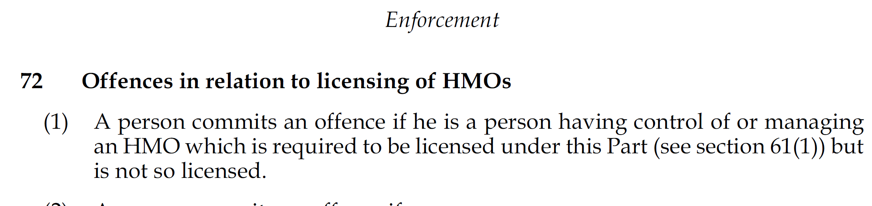
- The offence of not licensing, for which this application for a Rent Repayment Order was made is that at 72 (1) of the HA 2004:

- The key word under 72(1) is “so”: the property must be licensed in accordance with this Part of the Act. The necessary conditions for licensing are that an “appropriate person” be the licence holder (The Housing Act (HA) 2004 s64(3)(b)(ii)). “Appropriate person” is defined under s73(10) as “the person who at the time of the payment was entitled to receive on his own account periodical payments payable in connection with such occupation”: clearly this is the new HMO owner and the Respondent in this case.
- The property was not licensed by the appropriate person, the new owner, and therefore was not “so” licensed under this Part of the Act.
- The Upper Tribunal (UT) case HA/18/2014 Urban Lettings (London) Ltd v LB Haringey (2015) considers the nature of an “appropriate person” under the Housing Act (HA) 2004 in a RRO case where the appellant claimed not be “the appropriate person” due to lack of control over the common areas of the HMO and therefore should not have been a Respondent for the RRO application. This case is relevant because the decision, at the UT, is derived from the consideration of the policy of the HA 2004, as we have argued here at §4 above.
- At §22 of the above decision the Respondent, LB Haringey, argued that to accept the appellant’s position “would drive a coach and horses through the enforcement provisions of s 73(5) of the 2004 Act. In particular no-one would be liable for an RRO even though the premises were unlicensed and rent /housing benefit had been received.” This resonates strongly with the situation in the current case.
- At §24, the UT remarks on the purpose of the licensing regime, introduced through HA 2004:

In the current case, the new owner, continued to run the property as a HMO after purchase in 2016 until today without a licence. They were in receipt of rents throughout this period, no temporary exemption notice or provisional licence had been granted, nor was there any interim management order. As the Respondent had no licence they were not in a position to comply with any conditions. Therefore, the principle purpose of the licensing regime, identified so clearly in the UT case, was thwarted. To disallow a RRO application in this case would therefore run directly against the main purpose Part 2 of the HA 2004.
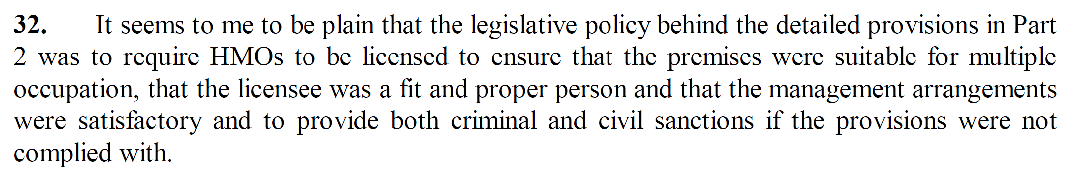
- The UT analyses the policy of the Housing Act 2004 in §26-32 of its decision and concludes:

- If the decision in the current case were to be upheld, none of the three above aims of the HA 2004, established in the UT case, would be achieved: there would be no check on the owner while it remained unlicensed and would likely stay unlicensed, with no checks on the property and with the new owner enjoying impunity from, at least, RRO sanctions and tenants unable to apply to get their rent back. All the time the tenants would be unprotected by the HA 2004. This situation is therefore inconsistent with the intention of the legislature.
- The decision reports on dates regarding licence application and issue dates. Some dates are quoted from correspondence from Ms Kath Stent at The Royal Borough of Greenwich (RBG). The appellant has made an official complaint to RBG regarding the dates and information Ms Stent has/has not supplied and their accuracy. The Tribunal has realised itself the inconsistency of information supplied by Ms Kath Stent at §3 of the decision. At §4 there are further inaccuracies: the reference by Ms Stent to an application date on 8th June 2017 was for a different property owned by the Respondent and no reference to this application is made in the respondent’s bundle. The application on 12th May, mentioned also in §4, was clearly not complete as the respondent’s accompanying letter in their bundle admits that obligatory documentation was missing (p68).
- It is also stated at §4 “Following the introduction of a new additional licensing scheme on 1st October 2017, Ms Stent stated that the Respondent was invited to resubmit an application online and that they did so on 31st March 2018”. We do not see the relevance of the new additional licensing scheme here: the property was licensable under a mandatory HMO licensing obligation and would not have been subject to the new additional scheme.
- It appears that the Respondent did not submit an online application as requested above. There is no reference to such an application in the Respondent’s bundle and the email from Opeyemi Alabi of The Royal Borough of Greenwich (RBG) at p77 of the bundle implies at §3 that no such application was made. There is no confirmation in any of the bundles that an application was made on 31st March as stated by Ms Stent.
- The licence was not granted on 6th September 2018 as stated in §4 of the decision: this was only a proposal to grant a licence. This proposal is in the Respondent’s bundle at p80. Ms Carole Zelenka, head of Environmental Health at RBG, confirmed in her email of to the Tribunal and Flat Justice of 26th February 2019 that no licence has yet been issued for the property (attached here). This means the property has been unlicensed for two and a half years since purchase.
- None of the dates of application provided in correspondence by RBG appear to be either correct or for a valid application. The respondent’s bundle contains a copy of the licence proposal from RBG of 6th September 2018 which clearly shows that the valid application date was 10th April 2018. It is this date that we hold to be the earliest valid application date.
- As the licence proposal was only issued on the 6th September, some 5 months after a supposedly valid application, it may be that a later application date is relevant: it would not normally take so long to issue a proposal and there may have been reasons for that. That a licence has still not been issued for the property again suggests that there were severe problems with the application or process and that the original application on 10th April may have been incomplete in some way.
- However, for the purposes of this case, any date from 10th April on makes little difference as only 12 months’ rent may be applied for. As the application date of 10th April is beyond the 5th April 2018 specified in the commencement regulations, this case should be assessed according to The Housing and Planning Act 2016 (HaPA): notably the rent that is applied for is not limited to 12 months prior to application as it was under HA 2004. We refer to the letter of Flat Justice CIC of 28/12/2018 to the President of the Tribunal Ms Siobhan McGrath, attached here and note that the form RRO1 was subsequently amended by withdrawing the ’12 months prior’ stipulation (correspondence attached).
- I submit the arguments prepared by Flat Justice regarding assessment under HaPA 2016 concerning the deduction of landlord costs. The phrase “reasonable in the circumstances” does not occur in chapter 4 of the HaPA 2016 and guidance in this regard from HA 2004 is not relevant.
This request for an appeal is to claim a Rent Repayment Order award of 12 months’ rent of £700/month immediately preceding the date of application for a licence by the Respondent of 10th April 2018, a total of £8,400.

